TDD JUNIT
Ex – 1: Setting up JUnit
package practice;

import static org.junit.Assert.assertEquals;

import org.junit.Test;

public class CalculatorTest {

@Test
public void testAdd() {

Calculator calculator = new Calculator();

int result = calculator.add(10, 20);

assertEquals(30, result);
}
}

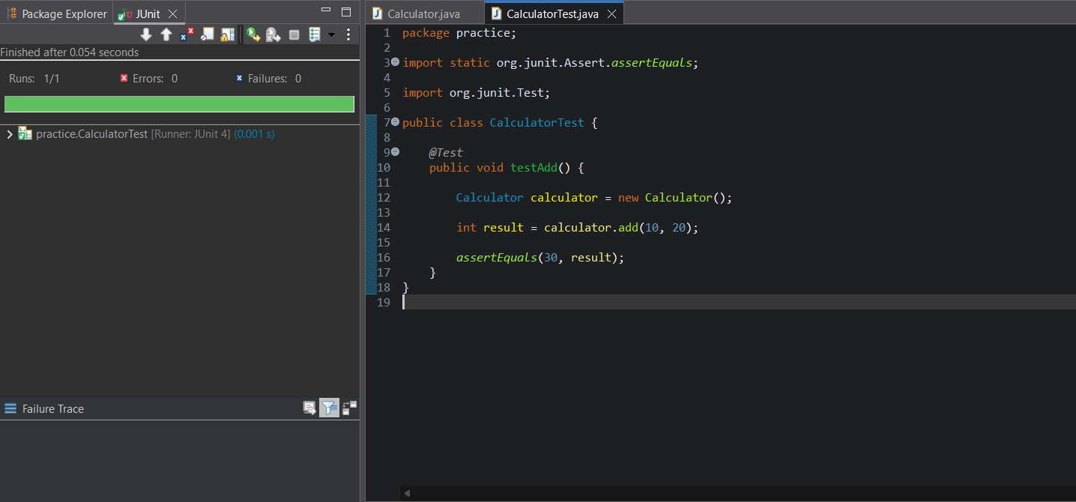

Ex – 3 : Assertions in Junit
package practice;

import static org.junit.Assert.*;
import org.junit.Test;

public class AssertionsTest {

@Test
public void testAssertions() {

// Assert Equals
assertEquals(5, 2 + 3);

// Assert True
assertTrue(5 > 3);

// Assert False
assertFalse(5 < 3);

// Assert Null
assertNull(null);

// Assert Not Null
assertNotNull(new Object());

}
}

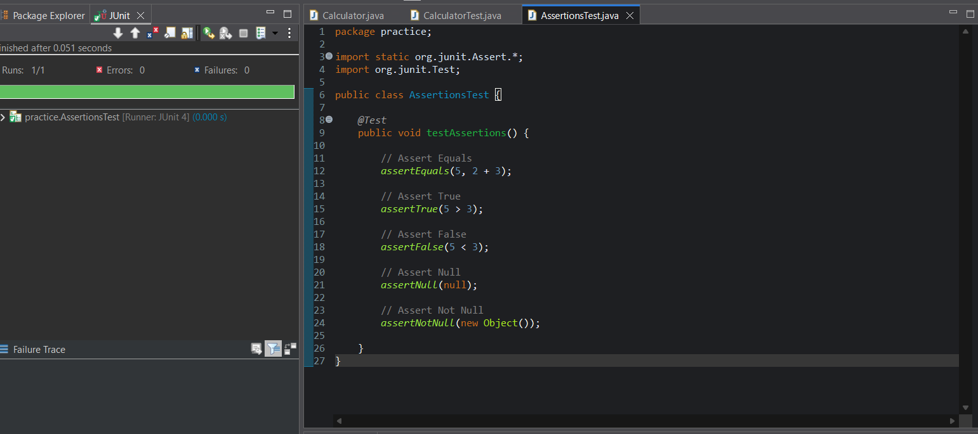

Ex – 4 : Arrange-Act-Assert (AAA) Pattern, Test Fixtures, Setup and
package practice;

import static org.junit.Assert.assertEquals;

import org.junit.After;
import org.junit.Before;
import org.junit.Test;

public class CalculatorAAATest {

private Calculator calculator;

@Before
public void setUp() {
calculator = new Calculator();
System.out.println("Setup: Calculator object created");
}

@After
public void tearDown() {
calculator = null;
System.out.println("Teardown: Calculator object destroyed");
}

@Test
public void testAdd() {

// Arrange
int a = 10;
int b = 20;

// Act
int result = calculator.add(a, b);

// Assert
assertEquals(30, result);
}
}
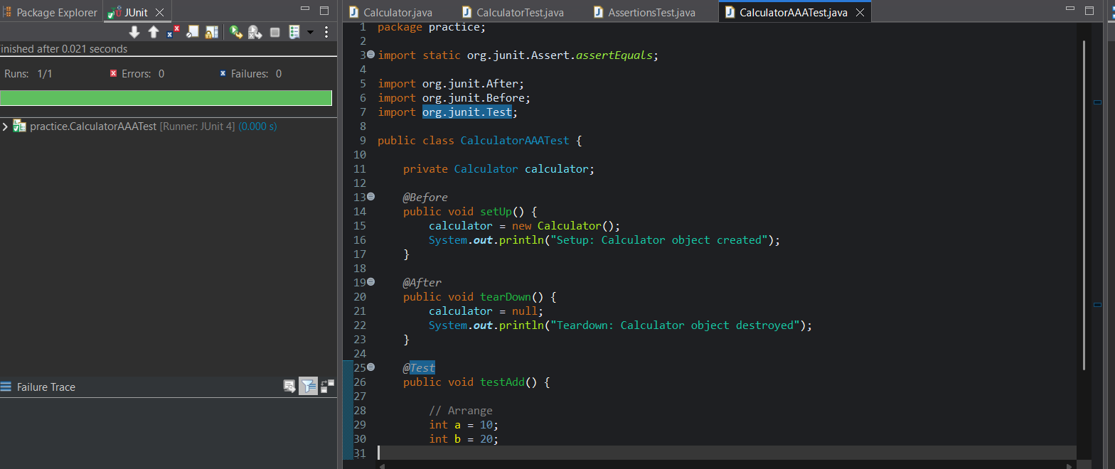

Ex – 1 : Mocking and Stubbing
package com.example.MockitoExample;

import static org.junit.Assert.assertEquals;
import static org.mockito.Mockito.*;

import org.junit.Test;

public class MyServiceTest {

@Test
public void testExternalApi() {

// Create Mock Object
ExternalApi mockApi = mock(ExternalApi.class);

// Stub the Method
when(mockApi.getData()).thenReturn("Mock Data");

// Inject Mock into Service
MyService service = new MyService(mockApi);

// Call Service Method
String result = service.fetchData();

// Verify
assertEquals("Mock Data", result);
}
}

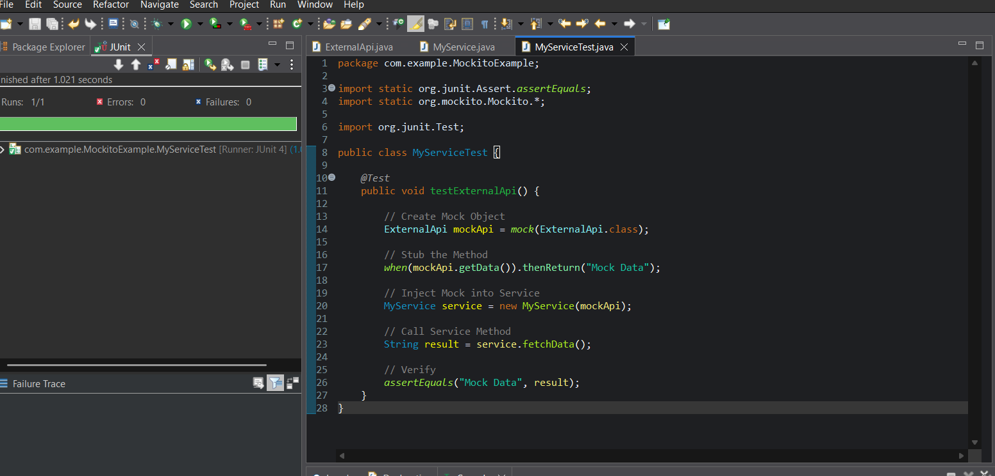
Ex – 2 : Verifying Interactions
package com.example.MockitoExample;

import static org.mockito.Mockito.*;

import org.junit.Test;

public class VerifyInteractionTest {

@Test
public void testVerifyInteraction() {

// Step 1: Create Mock Object
ExternalApi mockApi = mock(ExternalApi.class);

// Step 2: Inject Mock into Service
MyService service = new MyService(mockApi);

// Step 3: Call the Method
service.fetchData();

// Step 4: Verify that getData() was called
verify(mockApi).getData();
}
}

